**Project Design Phase**

**Problem – Solution Fit Template**

|  |  |
| --- | --- |
| Date | 05 March 2025 |
| Team ID | PNT2025TMID02901 |
| Project Name | Power BI Inflation Analysis: Journeying Through Global Economic Terrain |
| Maximum Marks | 2 Marks |

### ****Problem – Solution Fit Template****

### ****Problem Statement:****

Inflation is a significant economic factor that affects global markets, consumer purchasing power, and financial stability. Understanding inflation trends, their impact across countries, and key contributing factors is essential for governments, businesses, and individuals to make informed decisions.

### ****Purpose:****

The purpose of this Power BI dashboard is to:

* Provide a clear understanding of **global inflation trends** through visual insights.
* Enable stakeholders to analyze **country-wise economic impacts**.
* Assist businesses in identifying inflation-driven market shifts.
* Support policymakers in making **data-driven decisions** to control inflation.
* Offer an interactive and dynamic tool to explore **inflation data** with various filters for better analysis.

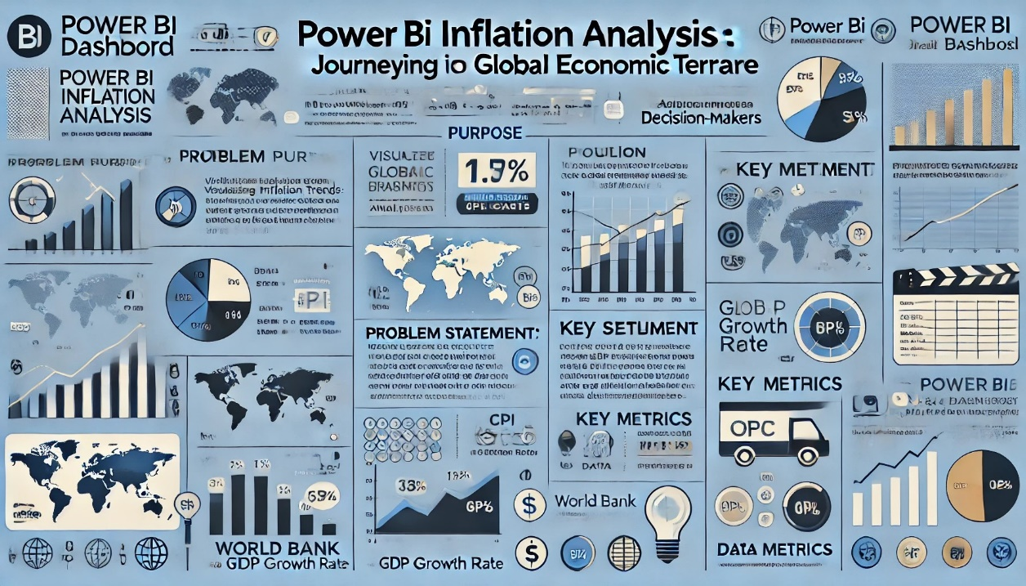**Template:**